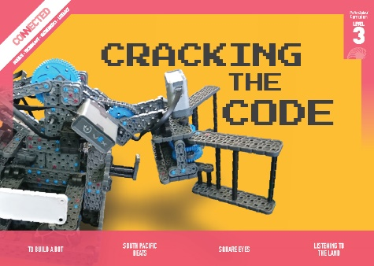
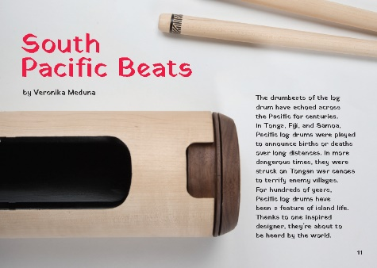
Connected
Level 3
2018

South Pacific Beats
by Veronika Meduna

Overview
This article describes how Wellington designer Rachael Hall developed a modern version of the traditional Tongan lali. Called Patō, Rachael’s drum keeps the traditional sound of a lali but incorporates digital capabilities. Her hope is that Patō will allow musicians to mix traditional Pacific sounds with modern music.
A Google Slides version of this article is available at www.connected.tki.org.nz
This text also has additional digital content, which is available online at www.connected.tki.org.nz
Curriculum contexts

SCIENCE: Physical World: Physical inquiry and physics concepts  Level 3 – Explore, describe, and represent patterns and trends for everyday examples of physical phenomena, such as movement, forces … sound, waves … For example, identify and describe the effect of forces (contact and non-contact) on the motion of objects …  Science capabilities  This article provides opportunities to focus on the following science capabilities:  - Use evidence  - Engage with science. | Key Nature of science ideas  - Sound is a form of energy that, like all other forms of energy, can be transferred or transformed into other types of energy.  - Sound is caused by vibrations of particles in a medium (solid, liquid, or gas).  - Sound waves can be described by their wavelength, frequency, and amplitude.  - The pitch of a sound is related to the wavelength and frequency – long or large vibrating objects tend to produce low sounds; short or small vibrating objects tend to produce high sounds.  - The volume of a sound depends on how much energy is used to create the sound – louder sounds have a bigger amplitude but the frequency and pitch will be the same whether a given sound is produced loudly or softly.
MATHEMATICS and STATISTICS: Geometry and Measurement – Measurement  Level 3 – Use linear scales and whole numbers of metric units for length, area, volume and capacity, weight (mass), angle, temperature, and time. | Key mathematics ideas  - Measurement is used in the process of sketching plans and building the prototypes and the lali.
ENGLISH: Reading  Level 3 – Ideas: Students will show a developing understanding of ideas within, across, and beyond texts. | Indicators:  - uses their personal experience and world and literacy knowledge confidently to make meaning from texts  - makes meaning of increasingly complex texts by identifying main and subsidiary ideas in them  - starts to make connections by thinking about underlying ideas in and between texts  - makes and supports inferences from texts with increasing independence.

TECHNOLOGY: Technological Knowledge: Technological products  Level 3 – Understand the relationship between the materials used and their performance properties in technological products.  Designing and developing digital outcomes: Progress outcome 1  In authentic contexts and taking account of end-users, students participate in teacher-led activities to develop, manipulate, store, retrieve, and share digital content in order to meet technological challenges. In doing so, they identify digital devices and their purposes and understand that humans make them. They know how to use some applications, they can identify the inputs and outputs of a system, and they understand that digital devices store content, which can be retrieved later. | Key technology ideas  - The attributes of materials are important considerations in design.  - Technologists build prototypes to test the performance properties of the materials used.

The New Zealand Curriculum

Technology

Meeting the literacy challenges

The main literacy demands of this text lie in the need to connect several different ideas: the importance of the lali to Tongan culture, the way instruments are made, the way sound works, and how digital technology can be added to enhance and/or distort analogue instruments.  The text includes a mix of sentence types and incorporates procedural text within an explanatory text. Quotes from Rachael provide important information and add authenticity and appeal.  The text is also interspersed with photos and diagrams, adding specific details and providing further explanations of scientific and technical ideas. Students will need to track the process for building a lali, which is outlined in a diagram, and then keep this in mind as they read about how Rachael designed and built the Patō. | Vocabulary challenges include Tongan names for musical instruments, as well as technical and topic-specific language. A glossary is provided for unfamiliar vocabulary not supported in the text.  The following strategies will support students to understand, respond to, and think critically about the information and ideas in the text. It may be appropriate to use all or only one or two of these strategies, depending on your students’ literacy knowledge and skills. You are encouraged to reword the suggested questions that will best suit your learners’ strengths and needs.  You may wish to use shared or guided reading, or a mixture of both, depending on the reading expertise of your students and the background knowledge they bring to the text.  After reading the text, support students to explore the activities outlined in the following pages.

INSTRUCTIONAL STRATEGIES

Making connections  TELL the students that they are going to read an article about a young woman who created a new musical instrument based on traditional Pacific log drums. In Tonga, these are called lali. Ask the students to share their experiences of hearing Pacific log drums being played. (You may not have Pacific students, but it is likely that some students will have heard Pacific log drums on programmes like Tagata Pasifika or when watching the Warriors play.)  PROMPT the students to make connections to the text by playing them the Tagata Pasifika item Electric Lali. (If you’re unable to play the video, have the students read the introduction and respond to similar questions such as those below). DIRECT the students to share their connections with each other and invite them to use this discussion to generate questions about the text.  What inspired Rachael to design a new musical instrument? Why did she do it? Who is it for?  Did you notice some words that are likely to be important when reading the article? Can you recall them? Do you know what they mean?  What else did we learn from watching the video?  What are some questions we could keep in mind as we read?  RECORD the students’ questions to return to later. | Finding information in the text  Check that the students understand the term “technological products” and that they have a clear understanding of what a technological outcome is. One way of doing this is by constructing a checklist, such as this one from the teacher support material for “Building a Wharenui”: A technological outcome is something that:  - people designed  - people made  - meets a need or an opportunity or solves a problem  - is not found naturally (that is, without human intervention)  - has physical attributes (for example, a car is large, heavy, hard to the touch)  - has functional attributes (for example, a car moves, its doors open and close, its boot stores things).  With this in mind, have the students SKIM and SCAN the text to find out how it is structured and to co-create a graphic organiser that will let them compare the traditional lali with the Patō. You and the students could create tables like the one below or use an app like Popplet to create Venn diagrams, with common features in the middle.  Lali Patō  Purpose  Physical attributes (how it looks, feels)  Functional attributes (what it can do)  Materials  Procedure  Basic scientific principles

Meeting the literacy challenges

Identifying the main idea  After the reading, have the students review their questions and DISCUSS their answers. Have them REVIEW the information they have summarised on their graphic organisers. With this in mind, ask the students to skim the text again to identify two or three brief passages (no more than two or three sentences) that capture the main ideas.  Working in small groups, have the students rewrite the sentences as simple statements. They can share these and discuss which is best. Use this discussion as an opportunity to PROMPT student thinking about the impact of new technology on traditional arts and culture. To help facilitate this discussion, you could show them an excerpt of the short video clip of digital artist Lisa Reihana’s Pursuit of Venus, summarising what this artwork is aiming to do.  Can you think of other examples of digital technologies being used alongside traditional art forms? What are they? What did you think of them? | Using design features for deeper understanding  EXPLAIN that the text has numerous photographs and diagrams. Remind the students of the importance of reading the headings, captions, and labels. Using the diagram on page 13, model how to connect the information in the captions with the details in the text to summarise what happens when a lali is struck.  Present the students with modified copies of the diagrams (for example, just the pictures in the diagram for building a lali and just the names for the diagram of Patō). Working in pairs, have the students take turns using their modified diagrams to explain what they are looking at. When the students are confident, you could invite selected pairs to present their explanations to the whole class.  Have the students use the diagram on page 14 as a MODEL for creating a similar summary of how the Patō is built. DISCUSS what you lose and what you gain by representing a process in this way.

TEACHER RESOURCES

Want to know more about instructional strategies? Go to:  - http://literacyonline.tki.org.nz/Literacy-Online/Planning-for-my-students-needs/Effective-literacy-practice-years-5-8  - “Engaging Learners with Texts” (Chapter 5) from Effective Literacy Practice in Years 5 to 8 (Ministry of Education, 2006).  Want to know more about what literacy skills and knowledge your students need? Go to:  - http://nzcurriculum.tki.org.nz/Assessment/Reading-and-writing-standards  - http://www.literacyprogressions.tki.org.nz/ | We have retained the links to the National Standards while a new assessment and reporting system is being developed. For more information on assessing and reporting in the post-National Standards era, see:  - http://assessment.tki.org.nz/Assessment-and-reporting-guide

Reading standard: by the end of year 6
The Literacy Learning Progressions
Effective Literacy Practice: years 5–8

Illustrating the key ideas

TEACHER SUPPORT
Sound is caused by vibrations of particles in a medium (solid, liquid, or gas).  Sound is a form of energy that can be transferred or transformed into other types of energy. | The pitch of a sound is related to the wavelength and frequency.  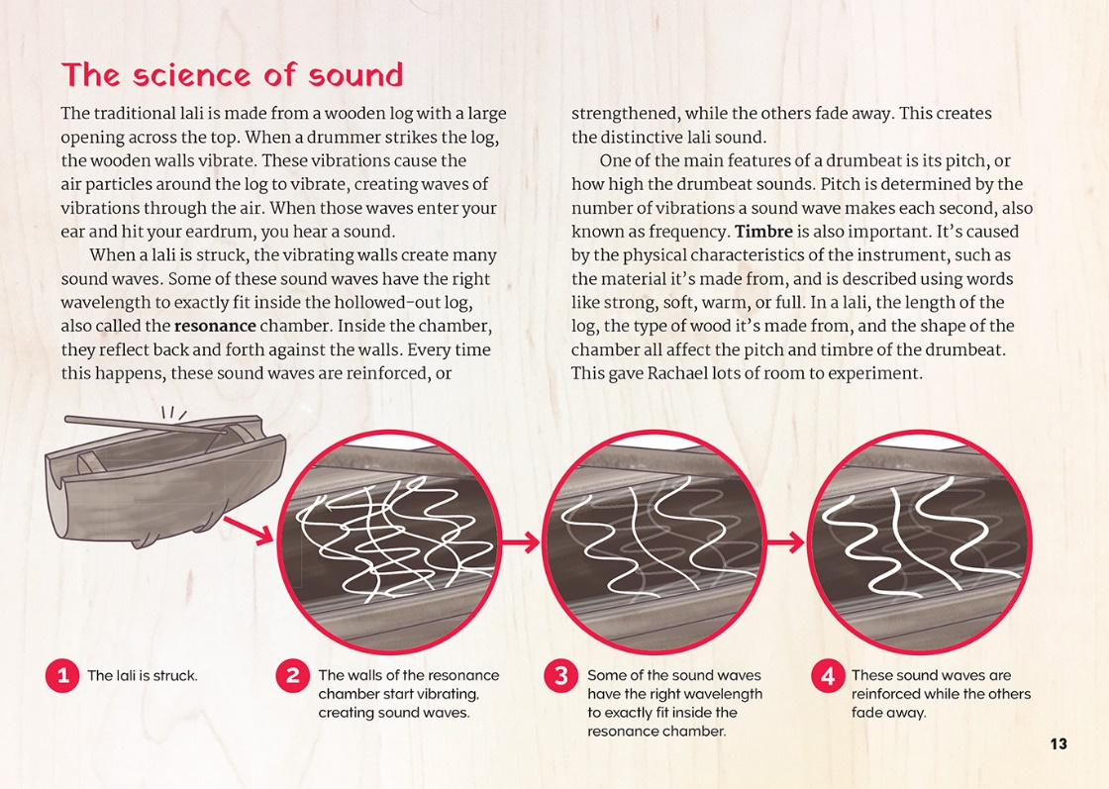
 | The materials used and their performance properties are important considerations for the development of technological products.

Learning activities – Exploring the science,
technology, and mathematics and statistics
The following activities and suggestions are designed as a guide for supporting students to explore and extend student content knowledge across the learning areas. Adapt these activities to support your students’ learning needs.

Activity 1 – Exploring concepts about sound and music
If they haven’t already done so, have the students use the diagram on page 13 to explain how a lali creates sound, using this as preparation for writing an explanation.
Have the students review the article to find the words about sound and then create a word web around each of these words. They could start by locating the definitions in the running text, the glossary, and the labels.
Have the students add depth and detail to their definitions through activities such as the following:
- Use Building Science Concepts books 18 and 19 to explore sound and its properties through creating and using musical instruments and sound makers.
- Create or use a device that lets students observe the passage of sound waves and understand concepts such as “frequency”, “wavelength”, and “amplitude”. Slinkies are useful as is the oscilloscope activity from the Science Learning Hub.
- Take the front off of a piano or examine a guitar and look at the length, thickness, and tension of different strings. Have students listen to their sounds and observe how quickly they vibrate. What patterns are there? Try playing different strings loudly or softly. What changes and what stays the same?
- Have students blow through a straw and experiment with how the pitch changes when they change the straw’s length.
- Learn about resonance by blowing across the top of a glass bottle and experiment with how the pitch changes when they add water or use a different-shaped bottle. (They will discover that the specific note is formed because the air chamber in the bottle is the right size to fit that specific note. In other words, the air vibration that they create by blowing has lots of different possible notes, but the one they hear is the one that has a wavelength that fits exactly into the space in the bottle.) Note that it is the air column that vibrates, so adding more water will produce a higher note as the air column is shorter.
Many of these activities lend themselves to learning in mathematics. For example, the students will need to make measurements as they explore how changes in the length, size, or shape of their slinkies, straws, or bottles affect the sound. They could also draw graphs to record their observations.

Activity 2 – Using representations
Review the diagrams in the article and prompt the students to reflect on how the diagrams helped them to understand the text.
Discuss the features of an effective diagram and create a list of criteria. Have the students use the information in the article to create a diagram to show how the Patō produces sound. They could then use their criteria to evaluate their own and each other’s diagrams.
Have the students work in pairs to create diagrams that show Rachael’s design process. Prompt them to reflect on this experience, thinking about the value of diagrams, not just for presenting information but for helping us to focus on key ideas. In this case, these ideas are likely to include concepts about the importance of experimentation and of choosing the right materials. What have we learned from this experience that could help us with other learning?

Extension
Have the students apply this learning as they have a go at making or enhancing musical instruments of their own.

Activity 3 – Having a go
There are many ways that students could respond creatively and technologically to the ideas and concepts in this article. For example, they could:
- listen to a range of musical instruments and use the words they have learned to describe the sounds
- create a vocabulary list to compare electronic and acoustic versions of the same instrument, describing differences in timbre, volume, and pitch
- explore how music is “enhanced” through digital input
- explore instruments that have only one pitch and compare these with others that allow the player to change pitch and key.
Students could have a go at recording and mixing sounds, some found in nature and some created using an instrument. They could cut and paste their sounds on a device (such as an iPad or cellphone) and they could try out a free audio-editing program (such as Audacity or GarageBand). Challenge them to experiment.
What are your ideas?
What sounds could you gather?
What is the sound you want to create?
What digital tools could you try?
How will you record your ideas? Can you sketch this out in a diagram?
Is there another way you could do this?
What has or hasn’t worked?
How does your process compare with the one Rachael followed?
Students could also try designing, building, and testing their own designs. For example, they could:
- examine musical instruments in their own culture and explore how they could redesign them
- design and make a sound maker using found materials
- make their own musical instruments.
These activities could culminate in them presenting a performance that includes the use of digital technology.

Learning activities – Exploring the science, technology, and mathematics and statistics

RESOURCE LINKS

Building Science Concepts  Book 18 – Exploring Sound: Using Sound-makers and Musical Instruments  Book 19 – Properties of Sound: How Sound-makers and Musical Instruments Work  Connected and School Journal  “Building a Wharenui”, Connected 2011, Level 2, Structure  “Can you Hear That?”, Connected 2016, Level 4, Getting the Message  “Starting with Strings”, School Journal Level 2, August 2015  Science Learning Hub  Activity – modelling waves with slinkies: www.sciencelearn.org.nz/resources/576-modelling-waves-with-slinkies  Measuring sound: www.sciencelearn.org.nz/resources/573-measuring-sound  Sound on the move: www.sciencelearn.org.nz/resources/572-sound-on-the-move  Sound on an oscilloscope (activity): www.sciencelearn.org.nz/resources/582-sound-on-an-oscilloscope  Hearing: www.sciencelearn.org.nz/resources/574-hearing  Sound detectives (activity): www.sciencelearn.org.nz/resources/578-sound-detectives  Science project measures noise levels: www.sciencelearn.org.nz/resources/2141-science-project-measures-noise-levels  Other sources  Electric Lali: www.youtube.com/watch?v=ZmN9vpNmYZk  Massey University – Contemporary Tongan drum wins international acclaim: www.massey.ac.nz/massey/about-massey/news/article.cfm?mnarticle_uuid=A2AF7F38-1B85-4E6C-B928-B40C0DDE1989  The James Dyson Award: National runner up – Patō: www.jamesdysonaward.org/projects/pato/  RNZ – Pasifika drum strikes a chord: www.radionz.co.nz/national/programmes/ninetonoon/audio/2018627069/pasifika-drum-strikes-a-chord  Designers Institute of New Zealand Best Design Awards – Rachael Hall, Patō: https://bestawards.co.nz/product/student-product/rachael-hall-1/pato/  Lisa Reihana is the next Venice Biennale representative: www.stuff.co.nz/entertainment/arts/73237800/lisa-reihana-is-the-next-venice-biennale-representative  ECHO: Education through Cultural & Historical Organizations – Celebrate: song, dance, and story!: www.echospace.org/articles/377/sections/1089.html | Musical instruments of Oceania: www.metmuseum.org/toah/hd/muoc/hd_muoc.htm  Pate (Samoan): https://en.wikipedia.org/wiki/Pate_(instrument)  Free audio editing programs for music teachers: https://midnightmusic.com.au/2009/10/5-free-audio-editing-programs-for-music-teachers/  Musical instruments crafts for kids: www.artistshelpingchildren.org/musicalinstrumentsartscraftstideashandmadekids.html  Pass my exams: Physics – Pitch, loudness, and quality of musical notes: www.passmyexams.co.uk/GCSE/physics/pitch-loudness-quality-of-musical-notes.html  Slit drum: https://en.wikipedia.org/wiki/Slit_drum  Steve Spangler Science – Musical straw: www.stevespanglerscience.com/lab/experiments/musical-straw/; www.youtube.com/watch?v=8IRCIIDWQmw  The Physics Classroom – Resonance: www.physicsclassroom.com/class/sound/Lesson-5/Resonance  Peabody – white noise (audio file): http://peabody.sapp.org/class/350.868/lab/examine/whitenoiseA.wav  Museum of New Zealand Te Papa Tongarewa – Māori musical instruments: www.tepapa.govt.nz/discover-collections/read-watch-play/maori/maori-musical-instruments  Smithsonian Folk Ways Recordings – Pacific Islander songs, sounds, and signals: Musics of Samoa, Fiji, and Tonga (lesson plan with audio files): https://folkways.si.edu/pacific-islander-songs-sounds-signals-samoa-fiji-tonga/music/tools-for-teaching/smithsonian  Felt Magnet – 46 homemade musical instruments to make: https://feltmagnet.com/crafts/Music-Instruments-for-Kids-to-Make  Science Snacks – Straw Oboe: https://www.exploratorium.edu/snacks/straw-oboe  YouTube  How to make a Device To See The Sound: www.youtube.com/watch?v=vOsYzC2N0Vc&feature=youtu.be NOTE: This is not a video to show students; it is for the teacher to create the activity. Beware of the language!  Science – Transmission of sound: www.youtube.com/watch?v=GkNJvZINSEY&feature=youtu.be  Musical Instruments Sounds – Kids learning videos: www.youtube.com/watch?v=17V-bP1XEao  Hearing Test HD – Signal frequency: www.youtube.com/watch?v=H-iCZElJ8m0  NOTE: Instruction for students listening on headphones – For lower frequencies (below 1kHz) you might want to increase your volume, but don't forget to lower it later to avoid damage to your hearing.

Learning activities – Exploring the science, technology, mathematics and statistics

RESOURCE LINKS continued

Scientific American – Sonorous Science: Making Music with Bottles: www.scientificamerican.com/article/sonorous-science-making-music-with-bottles/  Scientific American – Sounds Science: Do-Re-Mi with straws: www.scientificamerican.com/article/sound-science-do-re-mi-with-straws/ | STEM Learning – What factors affect the pitch and volume of sound? (videos)  Real World Sound – Composer: www.stem.org.uk/resources/elibrary/resource/315610/what-factors-affect-pitch-and-volume-sound  Sound – Levitation video: www.stem.org.uk/resources/elibrary/resource/315610/what-factors-affect-pitch-and-volume-sound

